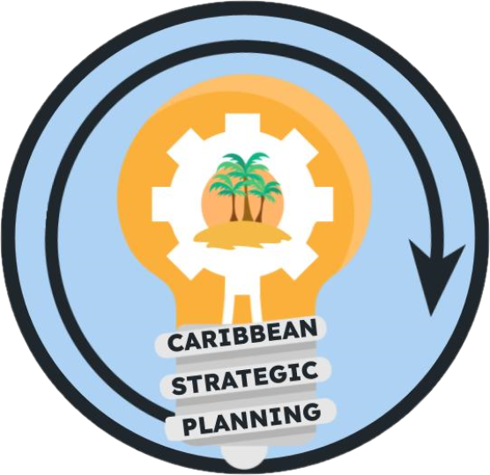Team Charter

Project: Develop FI data gap team to develop and prioritize data inventory

**Purpose**

Our purpose is to develop a fishery independent (FI) data gap team to describe the present data inventory for three survey targets: (1) reef fishes (0 - 450 m), (2) spiny lobster, and (3) queen conch. Data inventory will include associated temporal and spatial FI survey coverage gaps for fisheries management.

**Goals**

Our goals are:

1. Develop FI data inventories for three survey targets with respect to:
   1. Methodology
   2. Spatial extent
   3. Time series
2. Identify and describe time/space coverage gaps for three survey targets
3. Summarize findings (written report, final presentation, and FI data inventories)

Our ideal outcomes are to develop an inventory of FI data sources, identify spatial and temporal data gaps, and share the findings with stakeholders.

The deliverables will be a written report, final presentation, and FI data inventories

**Team**

* *Lead*: Kate Overly
* *Members*: Mike Feeley, Jay Grove, Tyler Smith, Steve Smith, Christian Jones
  + Will also include Eric Hoffmayer, Walt Ingram, Lee Richter, Jennifer Doerr, Juan J. Cruz Motta
* *Stakeholders*: CFMC, CIMAS, DNER/DRNA, DPNR, EBFM TAP, NOAA HQ, NPS, PRSG, QM/CI PSG, SEFSC, SERO, SSC, UPR, USC-A, UVI
* *KSAs*:
  + Queen conch: May need additional team members
  + Spiny lobster: Working group members
  + Reef fishes: Working group members

**Team Process**

* *Meeting day/time*: 1.5 hr meeting, 10:30 - 12 CDT/11:30 - 1 EDT/11:30 - 1 AST, Mondays
  + 2nd meeting August 28th at 10:30 - 12 CDT/11:30 - 1 EDT/11:30 - 1 AST
* *Meeting frequency*: 4-weeks
* *Decision-making procedures*: group consensus
* *Team communication*: e-mail, google drive documents

**Team Norms**

* *Values*:
  + Integrity, reproducibility, transparency, and communication of data
  + Innovation through adaptive management and continuous improvement
  + Respect and trust in data and partnerships
  + Diversity and inclusivity of data sources, data input, communities, and stakeholder ideas
  + Collaboration and cooperation in the collection and dissemination of data
* *Agreements*:
  + The Team agrees to work in an environment of mutual respect where all Team Members will be given an opportunity and encouraged to present ideas and viewpoints. Hand raising will not be needed during google meets as long as team members do not talk over each other.

**Supporting Resources**

* *Google Drive folder*: [Working Groups](https://drive.google.com/drive/folders/1GR0WWtq_eOGT89s0n8p1imwZ1ntcnczN)
* *Project facilitation*: Rachel Banton (rachel.banton@noaa.gov)
* *Process facilitation*: Richard Maclin, Vivian Matter (vivian.matter@noaa.gov), Jenny Suter (jenny.suter@noaa.gov)

**Metrics**

Success will be measured by a document that summarizes the FI data needs